

CSE 307 NETWORK ESSENTIALS

TOPIC: DESIGNING A NETWORK FOR A 8 FLOOR HOSPITAL using different types of topologies

SUBMITTED BY:

Shubhan S

Reg no:12306266

K23CH- G2

**Acknowledgment**

I sincerely appreciate everyone who contributed to the successful completion of this CA on Internetworking Essentials.

A special thanks to **Dr. Gagandeep Kaur**, my professor, for her valuable guidance, support, and encouragement throughout this project. Her expertise and feedback greatly helped me understand computer networking concepts and their real-world applications.

I am also grateful to everyone who played a part in making this project a success.

Shubhan S

Lovely Professional University

24/04/2025

AIM:

**AFTER MID TERM**

Reassign IP addresses to all floors using **FLSM**, with the **network address 189.16.0.0**. Implement the same network with additional services as described below:

**Additional Network Services:**

1. **IP Addressing:**
   * Implement **IPv4** addressing for all devices as per subnetting.
   * Assign **subnets** to each floor based on the number of devices.
2. **Server Configuration:**
   * **DHCP server** on the **1st Floor (General Wards & Pharmacy)**
   * **DNS server** on the **2nd Floor (Surgery & ICU)**
   * **FTP server** on the **4th Floor (Radiology & Pathology Lab)**
   * **Mail server** on the **Ground Floor (Reception & Emergency)**

We need to do Flsm (Fixed length subnet mask )

**AFTER MID TERM**

Reassign IP addresses to all floors using **VLSM**, with the **network address 189.16.0.0**. Implement the same network with additional services as described below:

**Additional Network Services:**

1. **IP Addressing:**
   * Implement **IPv4** addressing for all devices as per subnetting.
   * Assign **subnets** to each floor based on the number of devices.
2. **Server Configuration:**
   * **DHCP server** on the **1st Floor (General Wards & Pharmacy)**
   * **DNS server** on the **2nd Floor (Surgery & ICU)**
   * **FTP server** on the **4th Floor (Radiology & Pathology Lab)**
   * **Mail server** on the **Ground Floor (Reception & Emergency)**

Variable‑Length Subnet Masking (VLSM) allows networks to be partitioned with different subnet masks, tailoring each subnet’s host capacity to actual demand. By allocating large blocks to dense segments and smaller blocks to sparse ones, VLSM conserves IP addresses, facilitates hierarchical design, improves summarization, and maximizes routing efficiency across diverse topologies.

We need to use server to allocate DHCP as it automatically assign the ip .

A server is a specialized computer or software process that listens for requests over a network and delivers resources—web pages, files, databases, authentication, or applications—to clients. Equipped with robust CPUs, redundancy, and security controls, servers centralize data, enable collaboration, enforce policies, and keep services available to users around the clock.

We can do dhcp,dns,ftp and more with the help of server .

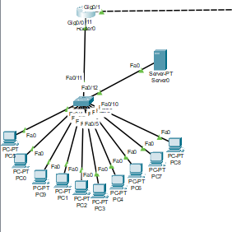

When we successfully assigned ip and joined it to the server we can make the use of server by clicking service .

Dhcp using server

Email :

Same for DNS:

WE can also do FTP (file transfer protocol ) :

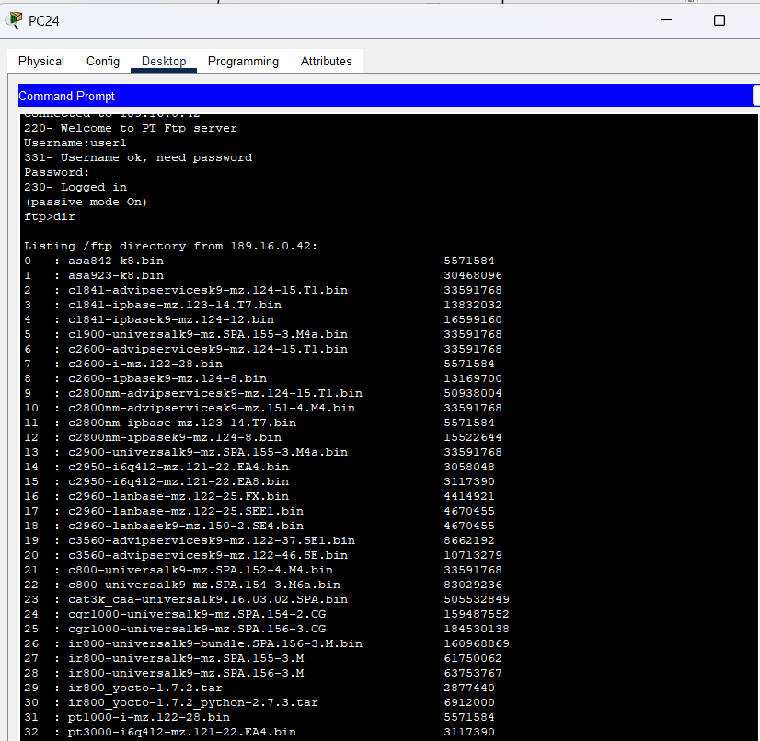

We have done this by assigning ip both manually and by automatically using dhcp so we have done vlsm and routed using static routing .

* **List all required subnets** based on the number of hosts needed for each.
* **Sort the subnets** from largest to smallest (by host requirement).
* **Calculate host requirements** for each subnet
* **Assign subnet mask** for each subnet based on its host requirement.
* **Start with the given network IP address**.
* **Assign the first subnet** to the largest group using the smallest suitable mask.
* **Calculate the broadcast address** of the first subnet.
* **Determine the next available network address** (1st IP after broadcast).
* **Assign the second subnet** starting from the new network address.
* **Repeat subnet assignment** for each remaining group in descending order.
* **Ensure no overlapping** between subnets.
* **Verify all host IP ranges** fall within the calculated subnet ranges.
* **Document subnet info**: network address, subnet mask, range, and broadcast.
* **Update routing tables** or configuration as required for each subnet.
* **Test connectivity** between subnets to ensure correct IP assignments and routing.

In this way we done vlsm for the given network of hospital in multi-story hospital the total network is :

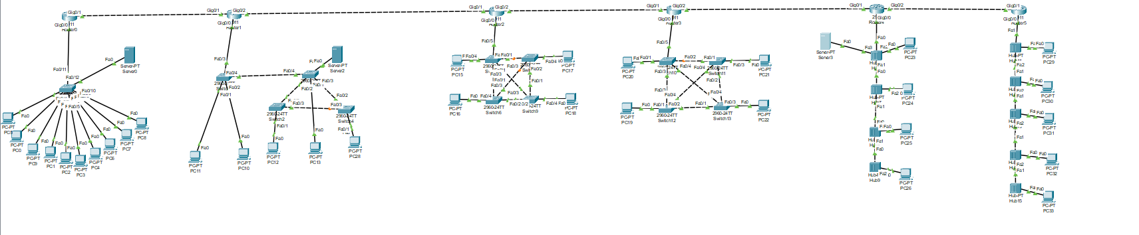

We can check its pinging :

In this way we have successfully done our project